**CP1406 Week 9 Practical – Publishing**

# For today’s practical, you need to submit:

* + **A link to your Assignment 1 homepage on SiteGround**

# Part 1 – Signing Up to SiteGround (If You Have Not Done So Already).

# If you have already signed up to SiteGround in Week 7, you can skip to Part 2. If you have not signed up, you will create an account on SiteGround to obtain web hosting space from SiteGround (free for 3 months). You will upload your assignment to the SiteGround web server later in the semester.

* Go to <https://www.siteground.com/studentsprogram>. Follow the instructions to create a user account. **You must use your JCU student email as your email address**.
* Check your JCU email for a confirmation email from SiteGround. It will contain important information you need to login to your new web space.
* Login to your web space using your SiteGround login. Make a note of your domain name. It will be something like: yourname.sgedu.site.

# Part 2 – Uploading Your Assignment 1 to SiteGround Using File Manager

# Now that you’ve signed up, you will upload your Assignment 1 to SiteGround to get yourself familiar with the uploading process.

* After logging in, click on the **Websites** link (Figure 1).

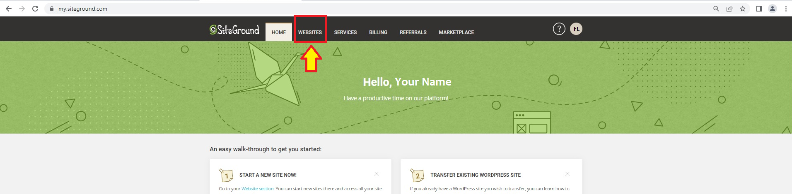

# Figure 1

* Click on “**SITE TOOLS**” (Figure 2).

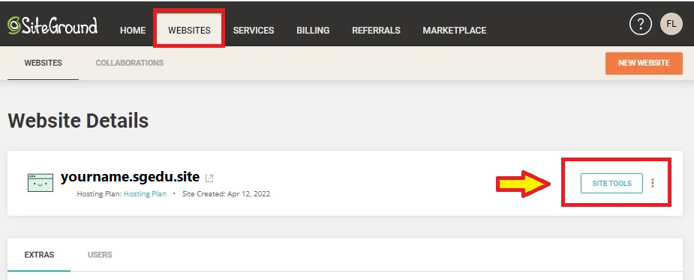

# Figure 2

* Click on “**File Manager**” (Figure 3).

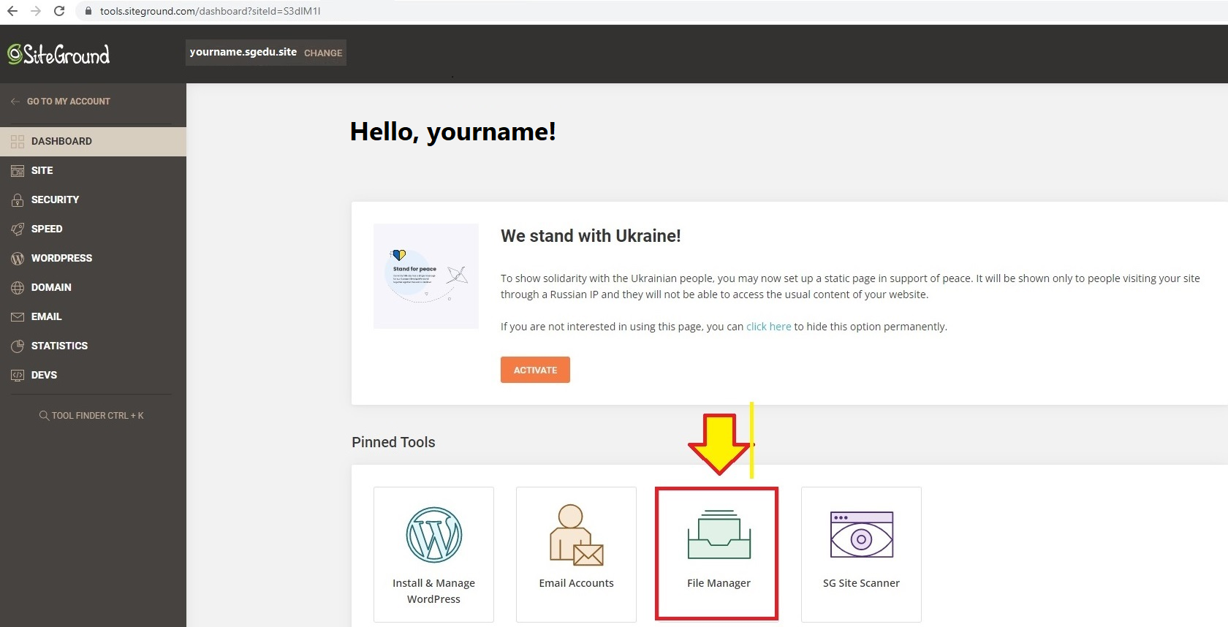

# Figure 3

* You should see the “**File Manager**” page as can be seen in Figure 4.
* Take notice of your site address on the top (green rectangle in Figure 4).
* Also take notice of the editor tool (purple rectangle in Figure 4). Here you can click on a file you’d like to edit and use the editor tools to amend the file – but usually you will edit your files on your own computer as we usually do.

# 

# Figure 4

* The folder “**public_html**” (rectangle in Figure 4) is where you are going to add your second assignment folder (refer to your Assignment 2 instructions).
* You can drag files and folders from your device and drop them in the “**public_html**” folder (see the blue rectangle in Figure 4).
  + I have dragged and dropped my folder “**a1**” to the folder “**public_html**”. I can now access my a1 homepage by visiting **yourname.sgedu.site/a1** (Figure 5).

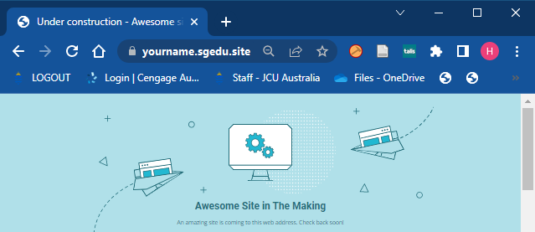

# Figure 5

* **Your Turn:**
  + If your assignment 1 folder is named something else other than a1, then change it to a1.
  + Drag and drop your assignment 1 folder, now called **a1**, to your **public_html**.
  + Access your a1 homepage via a desktop web browser as well as from your handheld device (mobile phone or tablet). Your a1 homepage link should look something like yourname.sgedu.site/a1

# Part 3 – Uploading Your Assignment 1 to SiteGround Using FTP

# You can use an FTP program such as WinSCP to transfer folders and files to your SiteGround web server.

* Back to your SiteGround website, on **File Manager**, delete the a1 folder from **public_html**.
* On your side navigation on the left, click on the “**FTP Accounts**” tab (Figure 6).
* You can create a new FTP account by adding an account name of your choice, and a password (**or** click “**GENERATE**” to generate a password for the account) (Figure 6).
* Click “**CREATE**” to create a new FTP account (Figure 6).

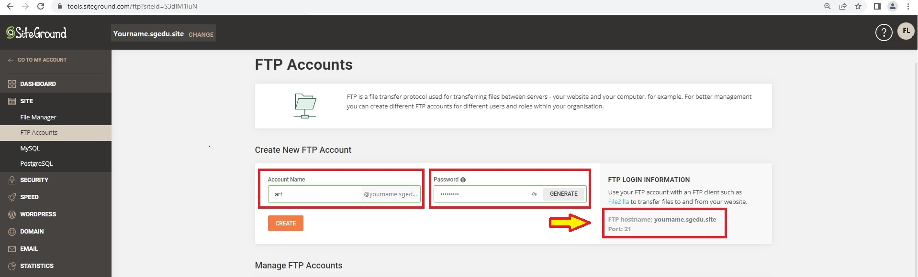

# Figure 6

* Take note of the FTP hostname (yourname.sgedu.site) and the port number (21), see Figure 6.
* Open WinSCP app in Windows (Figure 7).   
  If you are using your own computer for this, you can download:
  + for Windows, <https://winscp.net/eng/index.php>, or
  + for Mac users, <https://filezilla-project.org/> (also available for Windows).

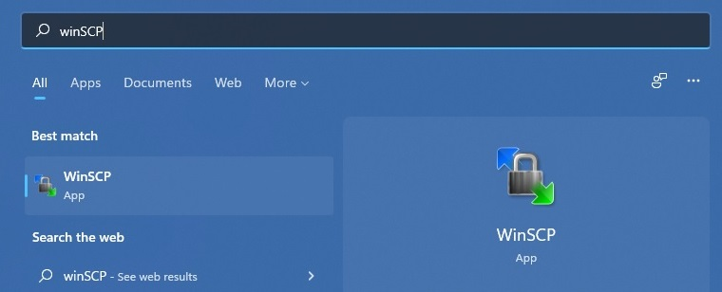

# Figure 7

* Fill in the information of your host name, port number, user name, and password, then click “**Login**” (Figure 8).

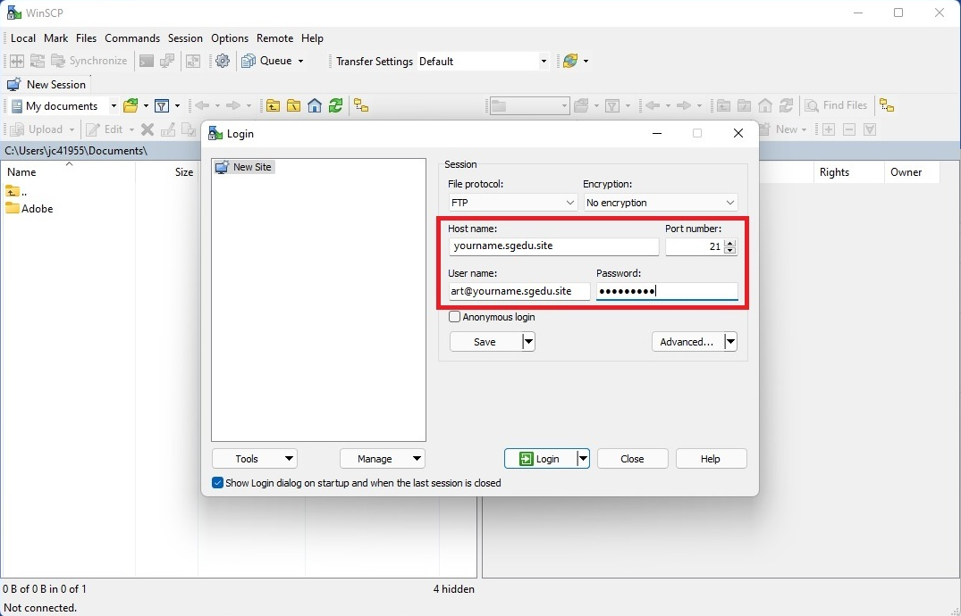

# Figure 8

* Once logged in, on your right pane, double click on “**yourname.sgedu.site**” folder (Figure 9).

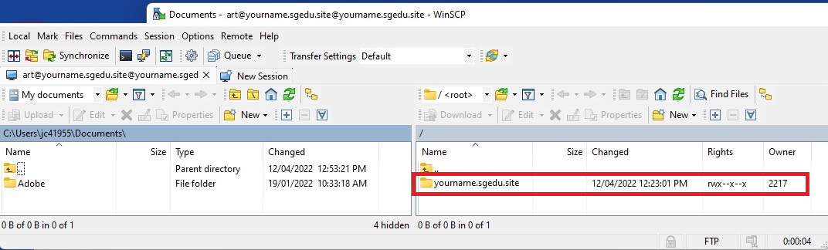

# Figure 9

* On the right pane, you will then see the folder named “**public_html**”, double click on the folder to access the folder (Figure 10).

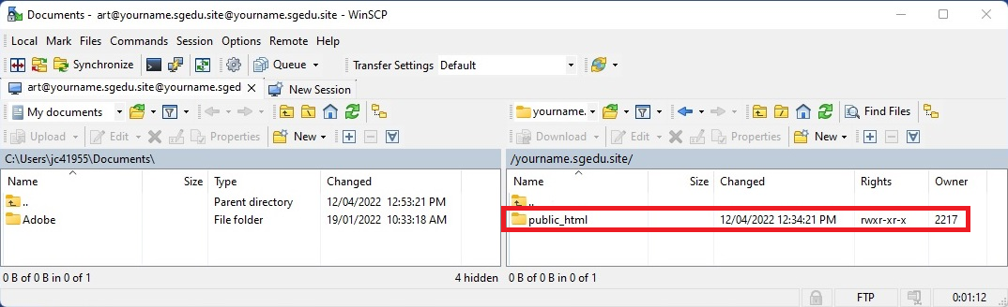

# Figure 10

* On the left pane, navigate to the folder you want to upload to your “**public_html**” folder. You can drag the folder from the left and drop it to the right pane (Figure 11a.). Alternatively, you can drag the folder from your device (without using the left pane) and drop it to the right pane (public_html folder), see Figure 11b. Click “OK” to upload (Figure 11c).

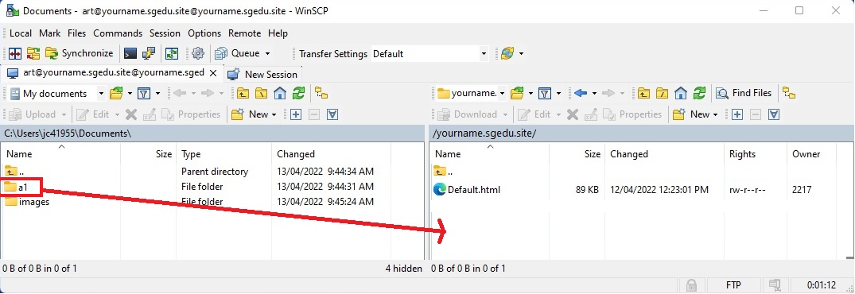 **(a)**

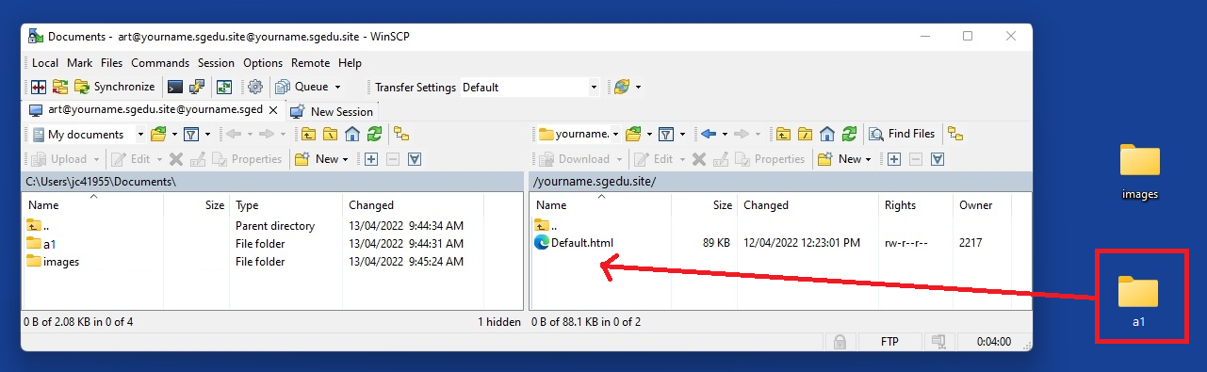 **(b)**

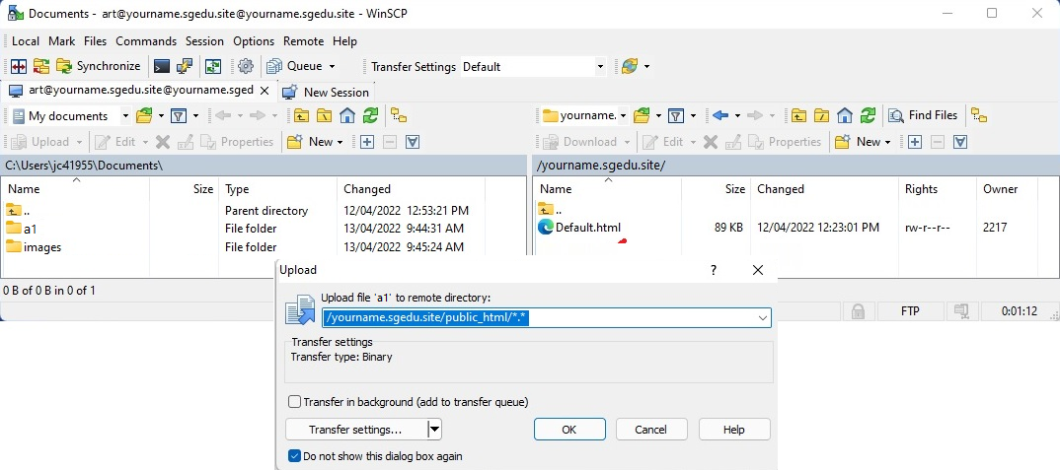 **(c)**

# Figure 11

* Revisit your **a1** homepage by visiting **yourname.sgedu.site/a1**.

# Deliverables:

* A link to your Assignment 1 homepage on SiteGround.